Mirror file download address:https://drive.google.com/file/d/1T0ujz3fpnjJrgNHiiyyxj5-it-ehK7cF/view
Step 1: Prepare a C1 SSD and copy the compressed image file vea_sdcard.img.xz to the SSD.
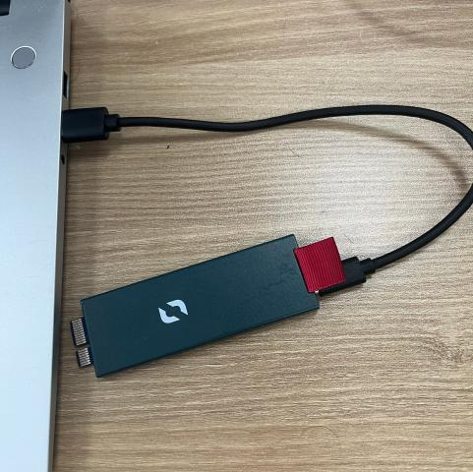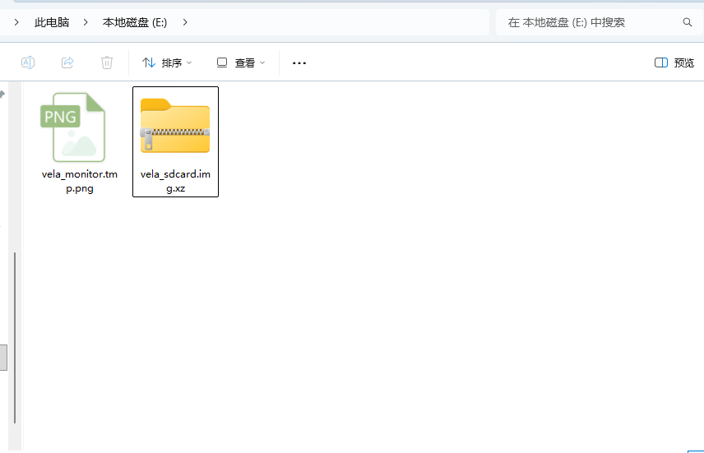
Step 2: Ensure that your Windows computer and the Vela device are connected to the same network. Insert the prepared C1 SSD into the Vela device.
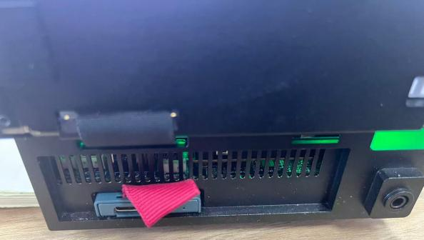
Step 3: Run Recover_Single.exe on your Windows computer, enter the Vela's IP address, then select "Check Device and Image." Wait for the check to complete, and based on the results, choose either SSD or USB drive as the recovery method.
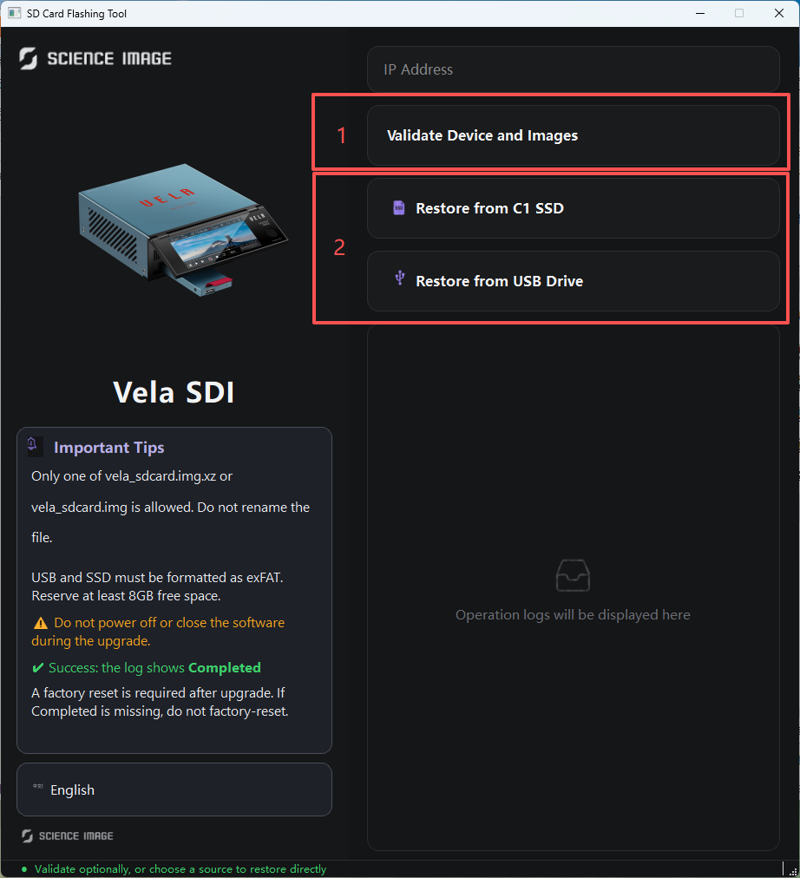
Step 4: After selecting either SSD or USB drive according to the check result, wait approximately 10 minutes until the log displays "completed."
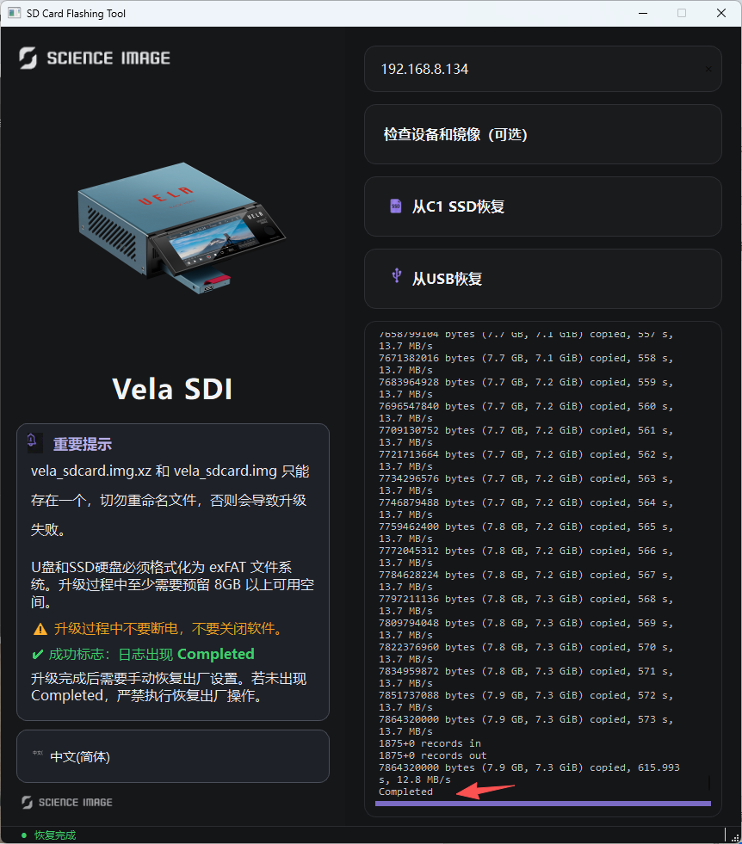
Step 5: Disconnect the power from the Vela device, then while reconnecting power, hold down the reset button in the small hole for about 5 minutes.
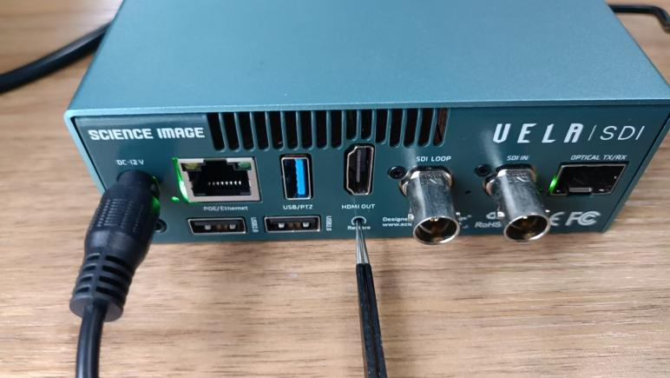
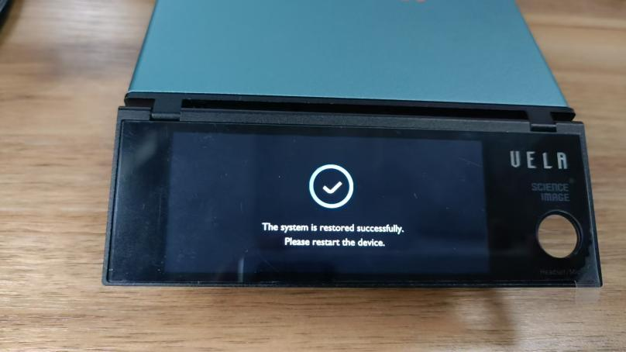

Step 6: Install the latest version of DynaTools, then use Dyna Hub to upgrade the Vela firmware to version siup-velars-260811a.