If the Vela firmware is siup-velars-260415a.dat or an earlier version, you must first upgrade the recovery card before updating to the latest version.

The recovery card upgrade procedure is as follows:
1.Download the SD card upgrade tool from the official website. Download link:
https://www.science-image.com/download/sd-card-flashing-tool
2.Download the image archive package from the official website. Download link:
https://drive.google.com/file/d/1T0ujz3fpnjJrgNHiiyyxj5-it-ehK7cF/view?usp=drive_link
3.Connect the computer and C1 hard drive via a Type-C to USB adapter, then place the image installation package in the root directory of the C1 hard drive. Do not rename the image file.
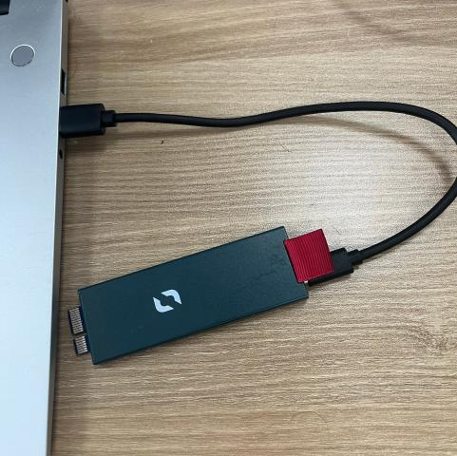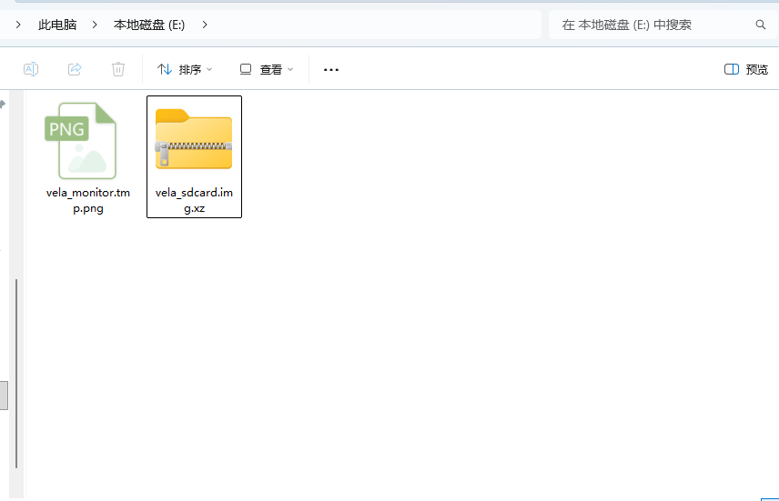
4.Reinsert the C1 hard drive into the Vela device and power it on.
5.Launch the Recover.exe file (SD card upgrade tool) on your computer.
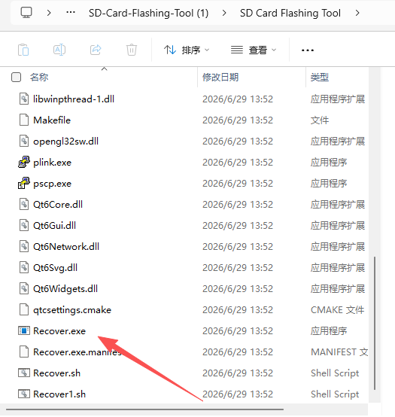

6.Enter the IP address of the Vela device and click "Restore from C1 SSD".Ensure that the computer and the Vela device are on the same network segment.
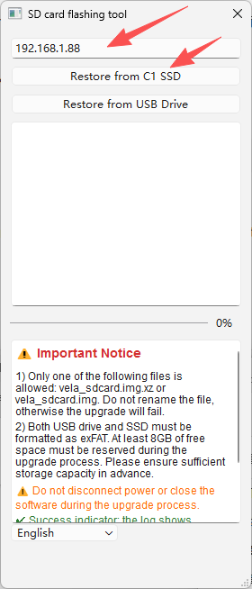
7.When the prompt "Completed" appears, the recovery card upgrade is finished.It will take approximately 10 minutes.
8.Perform restoration on the Vela device.
9.With the power off, press and hold the “Restore” hole and Do not release on the Vela device using a pin tool.
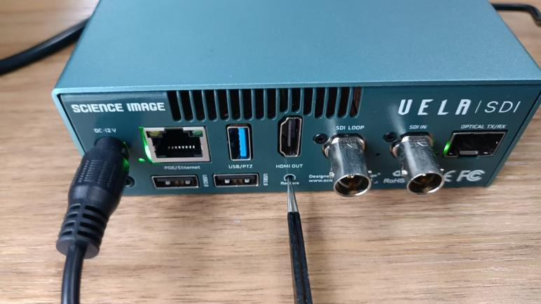
10.Supply power to the Vela device.
11.Release the pin tool after approximately 3 seconds, The TFT screen of the Vela device displays restoration prompts.
12.After approximately 10 minutes, the screen will show that restoration succeeded; you may then power off and restart the device.
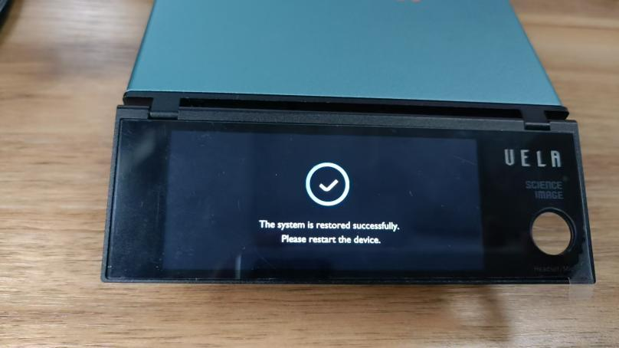
- Then download the new firmware of Vela and DynaTools,here is the link:
https://www.science-image.com/support/download
- Then upgrade the firmware with Dynahub (an individual tool in DynaTools ). Here is the video link:
https://drive.google.com/file/d/1EIvmCehjvj4FliVlWNMiRnxfQwswgrub/view?usp=drive_link

